**End-to-End Project for Data Pipeline and Reporting**

**Nachiket Prajapati**

**Batch:- NCPL (C-19)**

**Objective:** Build a complete data pipeline from on-premises data to cloud storage, process and clean data, and create reports using the Azure Data Lakehouse and Fabric.

### **Project Outline and Expected Outputs**

1. **Data Ingestion**
   * **Objective:** Ingest data from an on-premises environment to an Azure Data Lake Gen2 storage account.

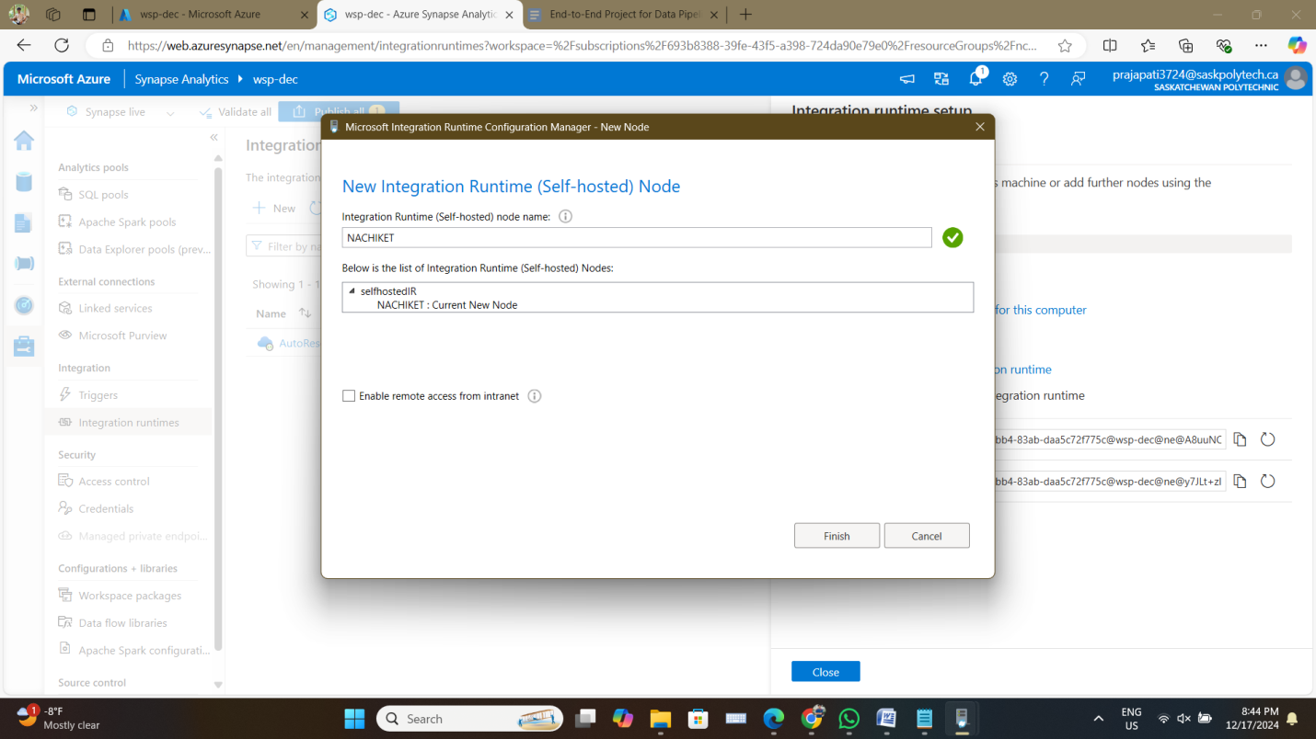

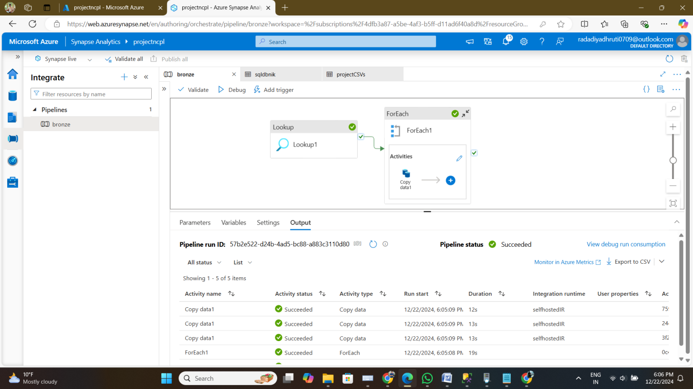

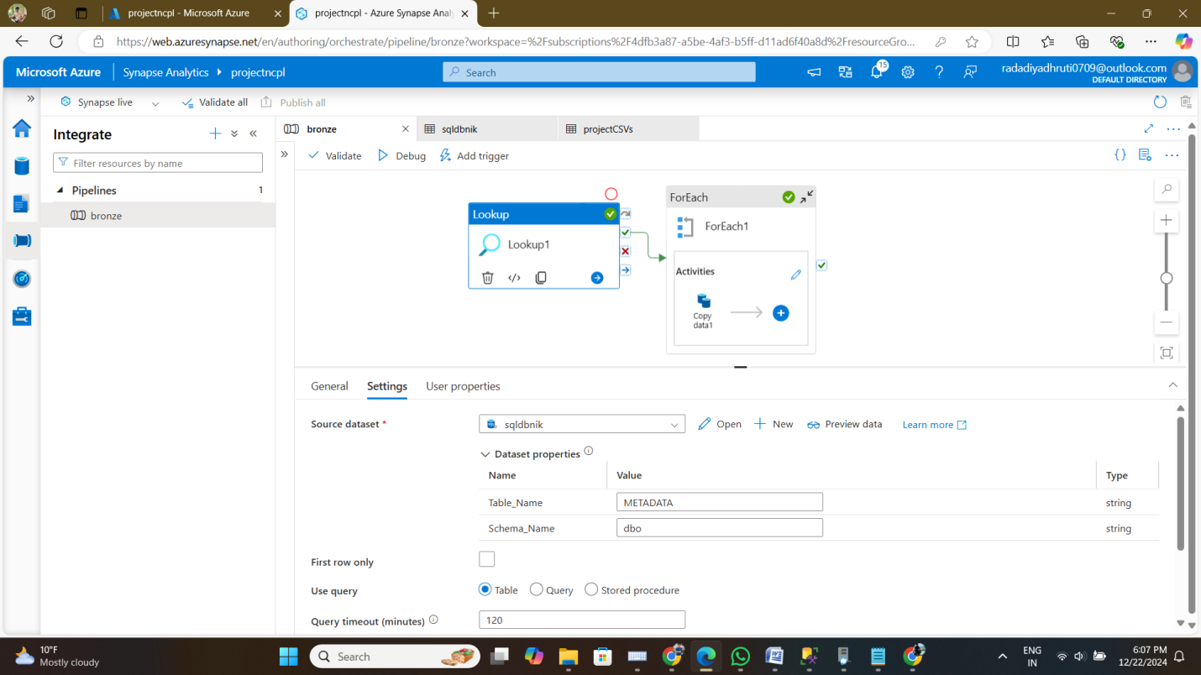

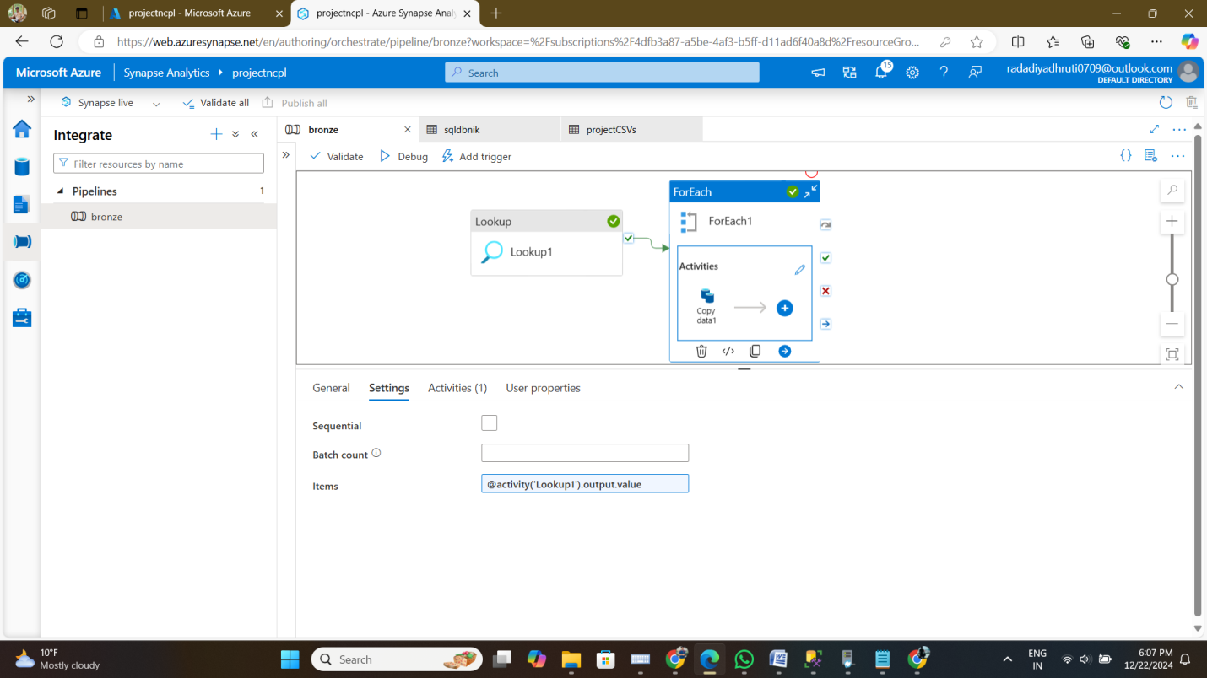

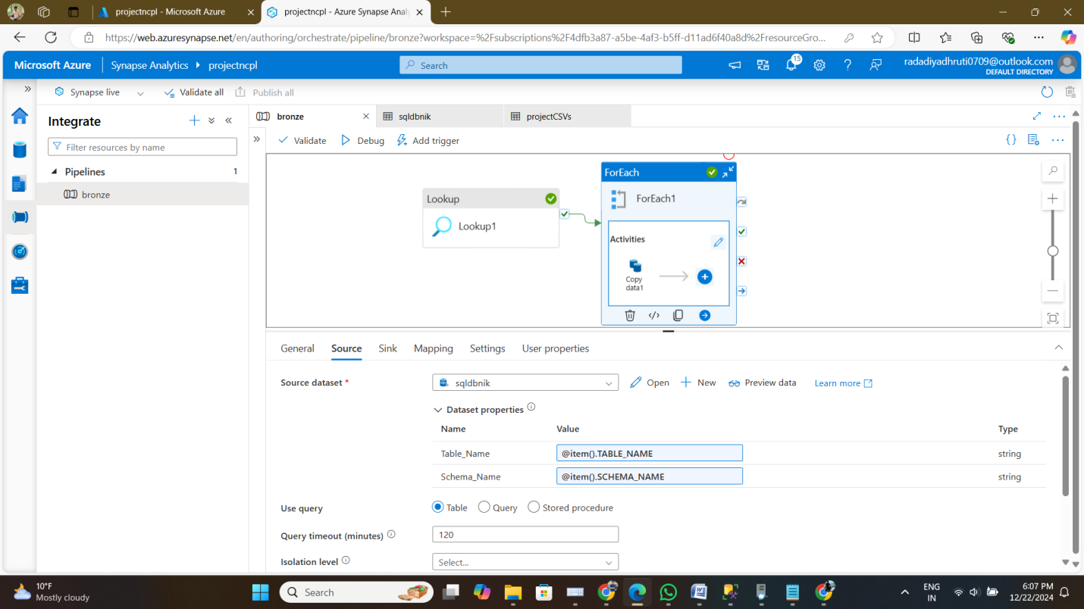

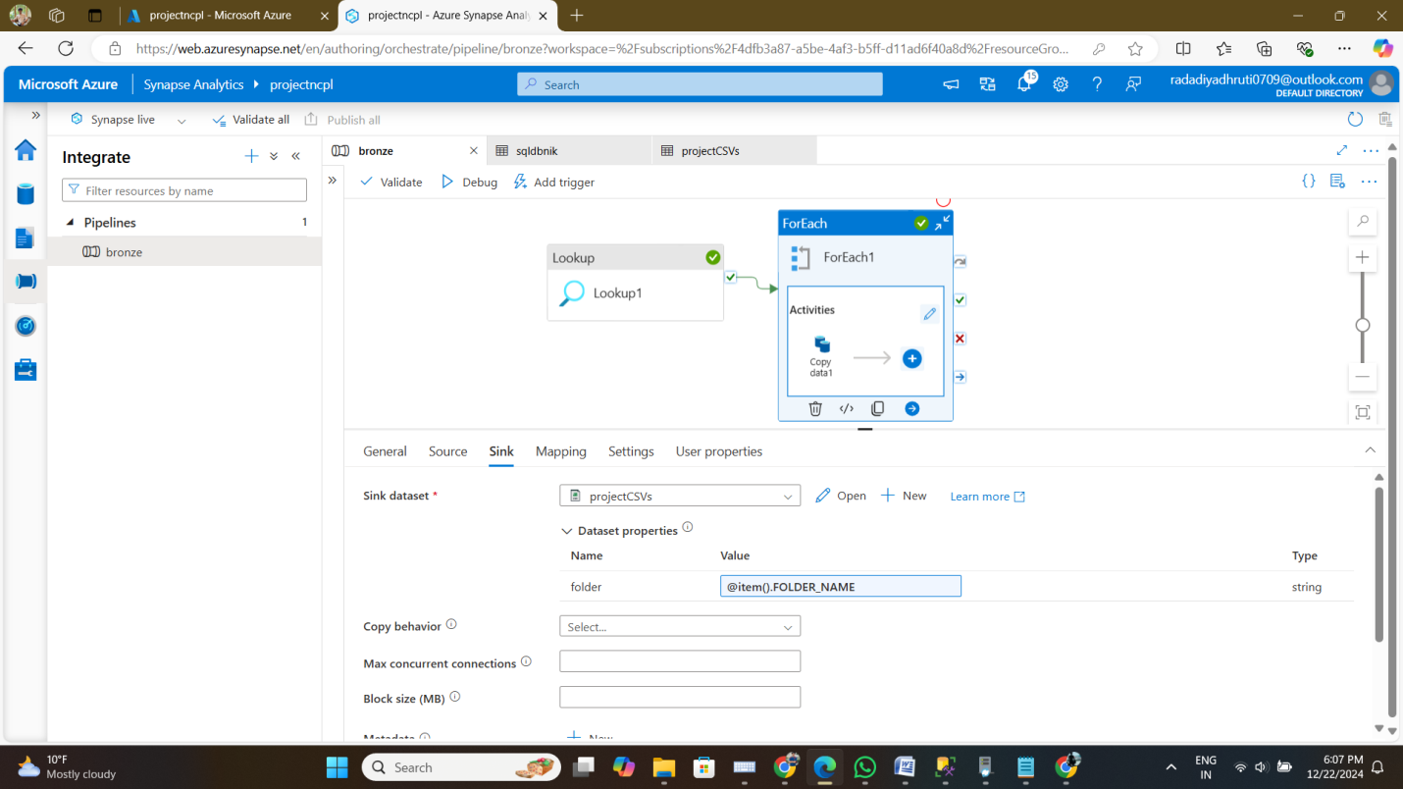

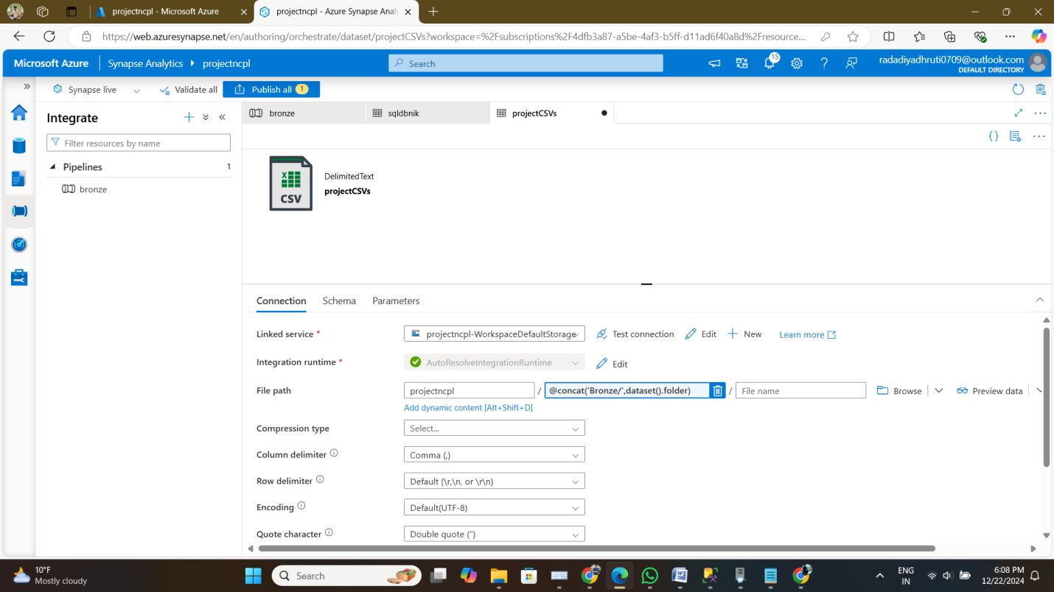

* + **Expected Output:**
    - A folder named **Bronze** in the Data Lake Gen2 storage account containing raw data in its original format.

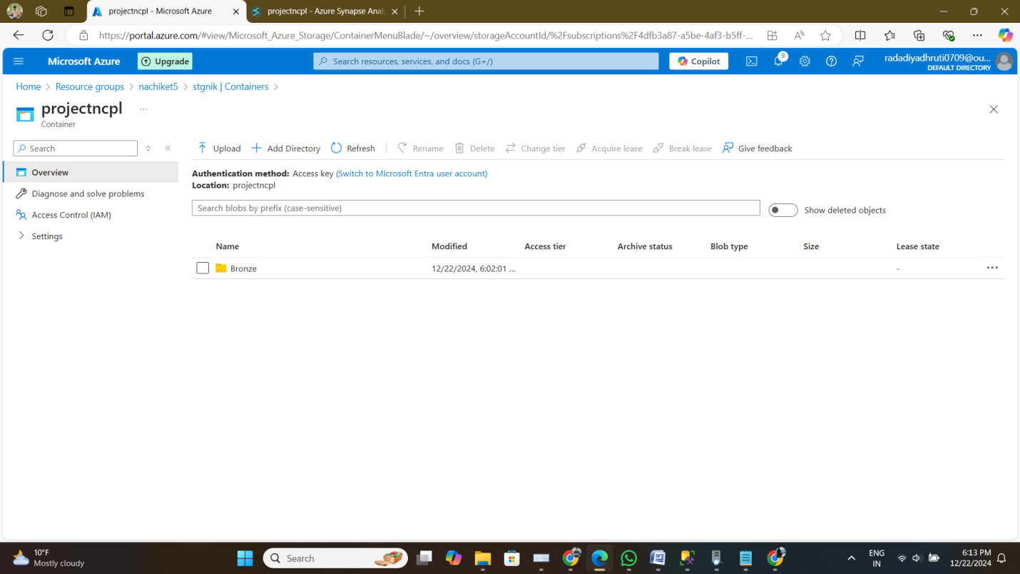

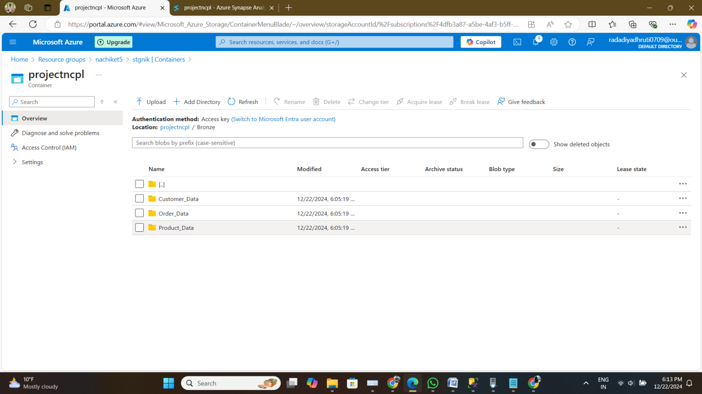

* + - Verification logs or metadata confirming successful data ingestion.

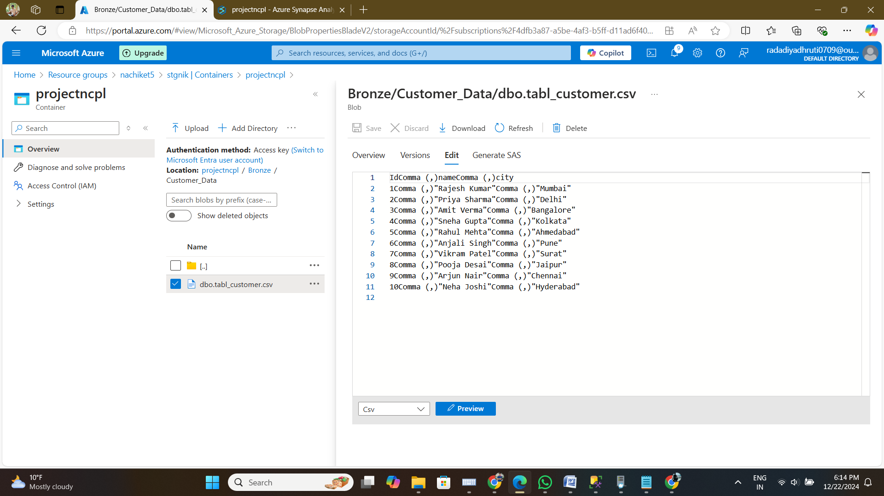

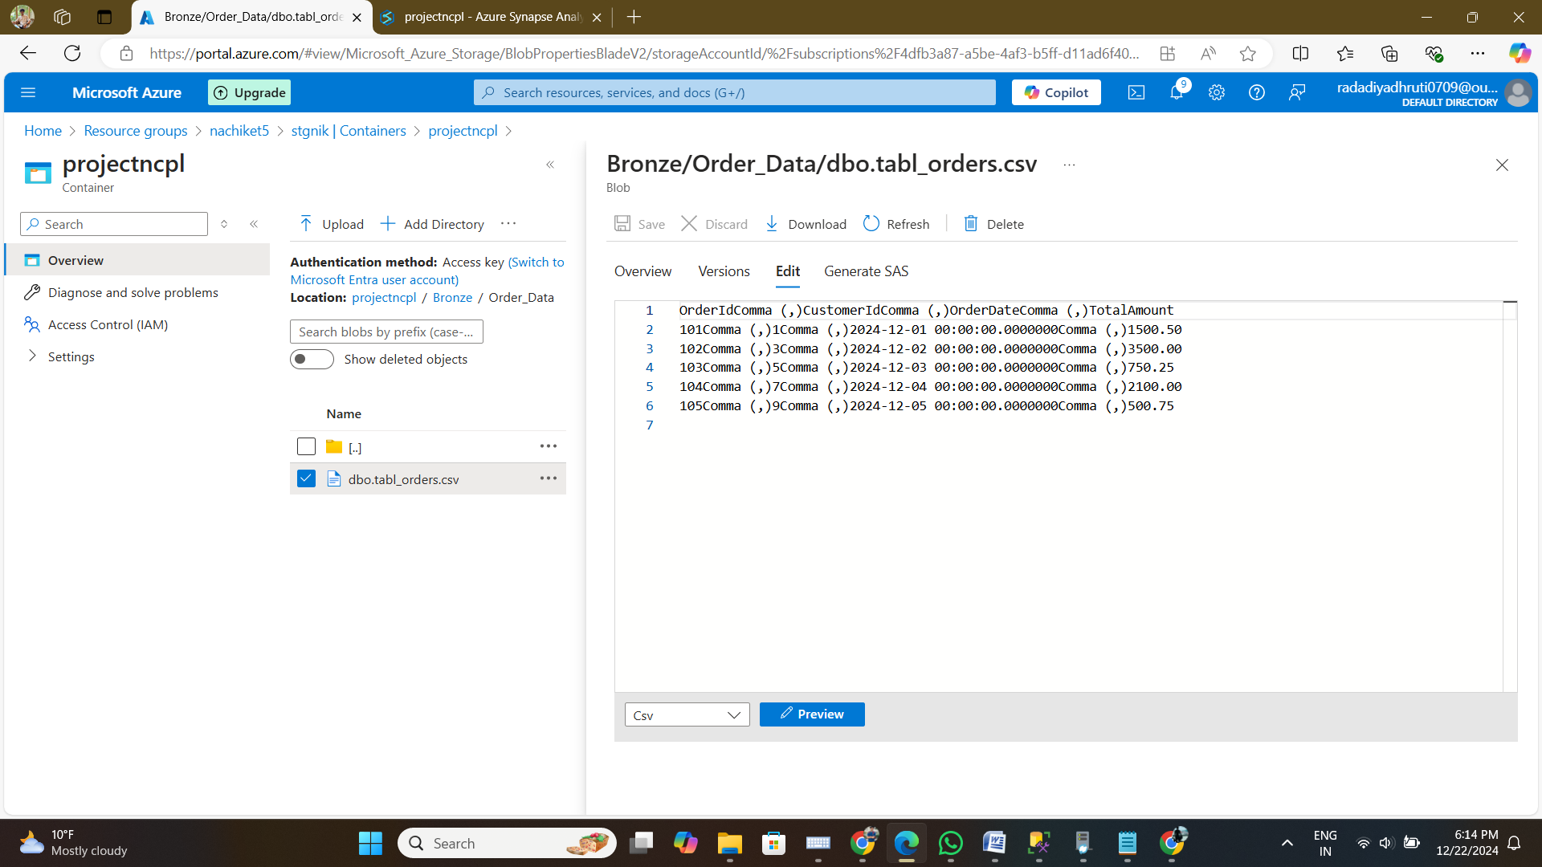

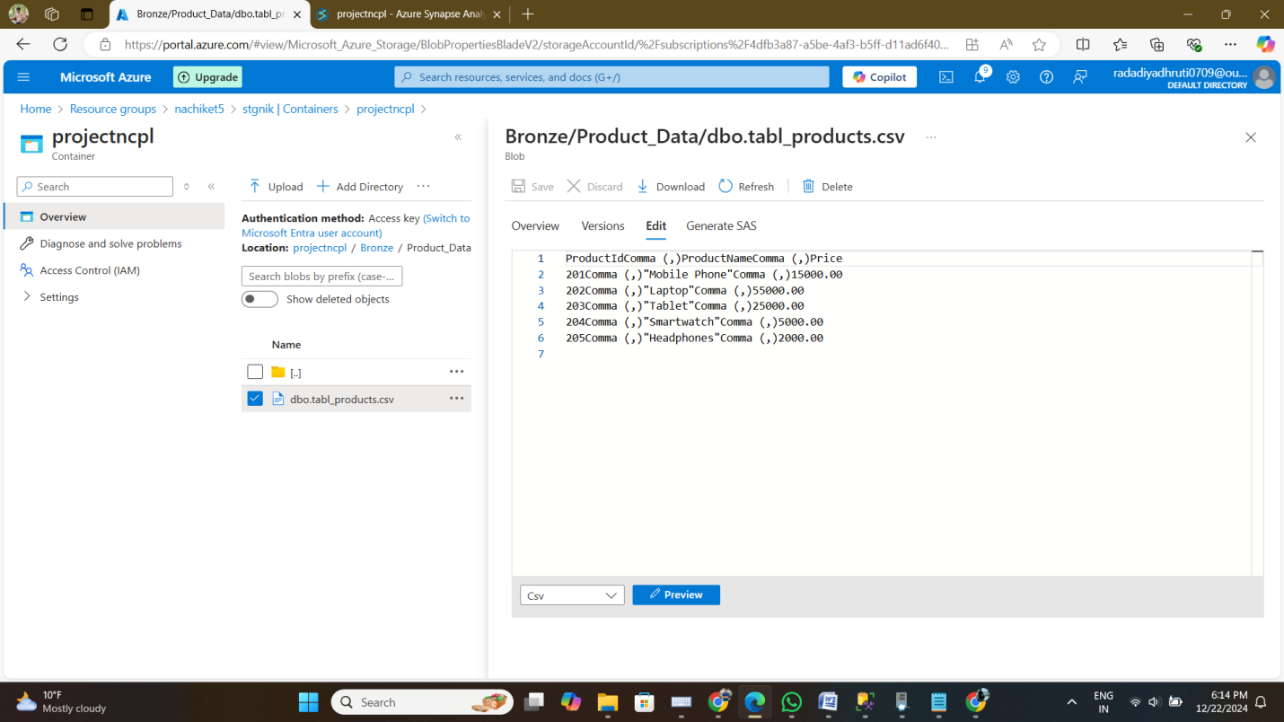

1. **Data Cleaning and Transformation**
   * **Objective:** Apply data cleanup techniques and convert the raw data into Delta format.

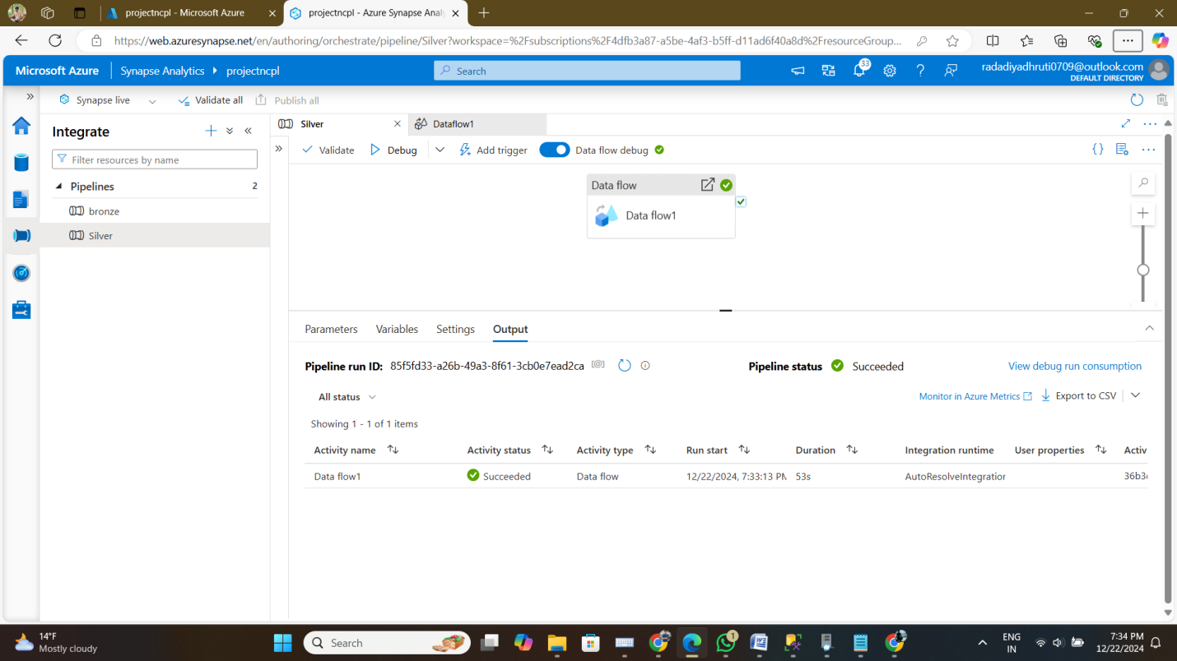

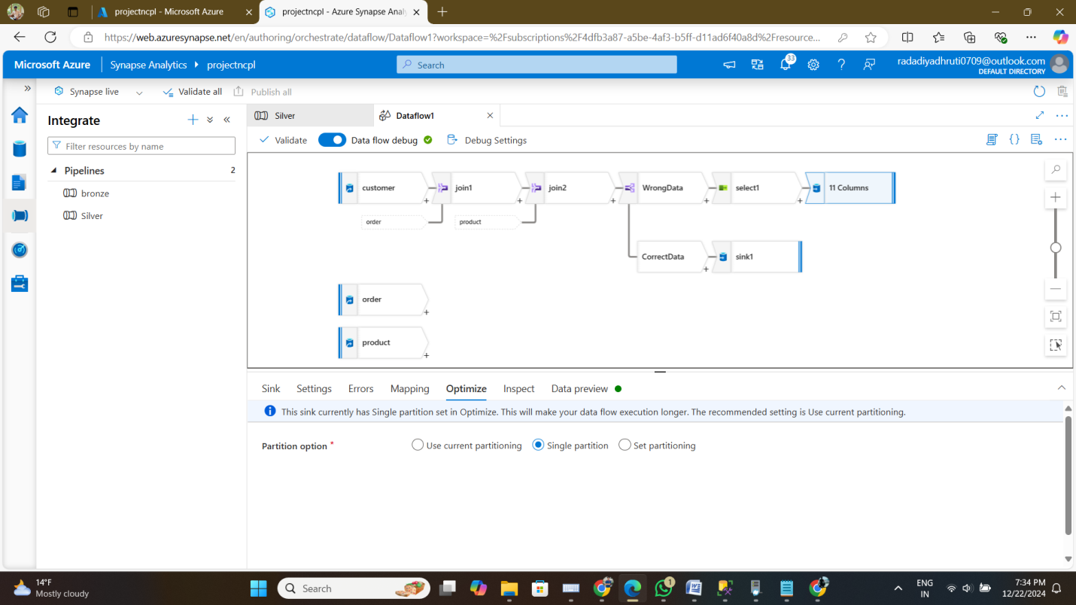

* + **Expected Output:**
    - A folder named **Silver** in the Data Lake Gen2 storage account containing cleaned and transformed data in Delta format.

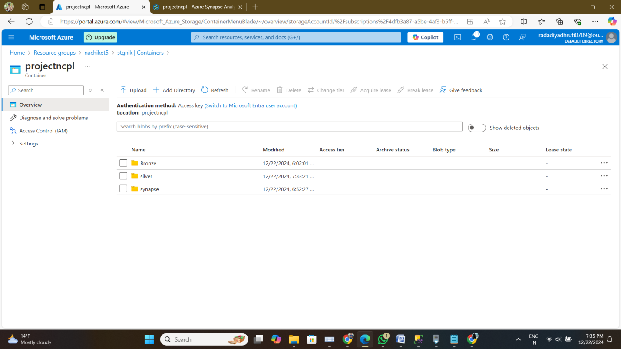

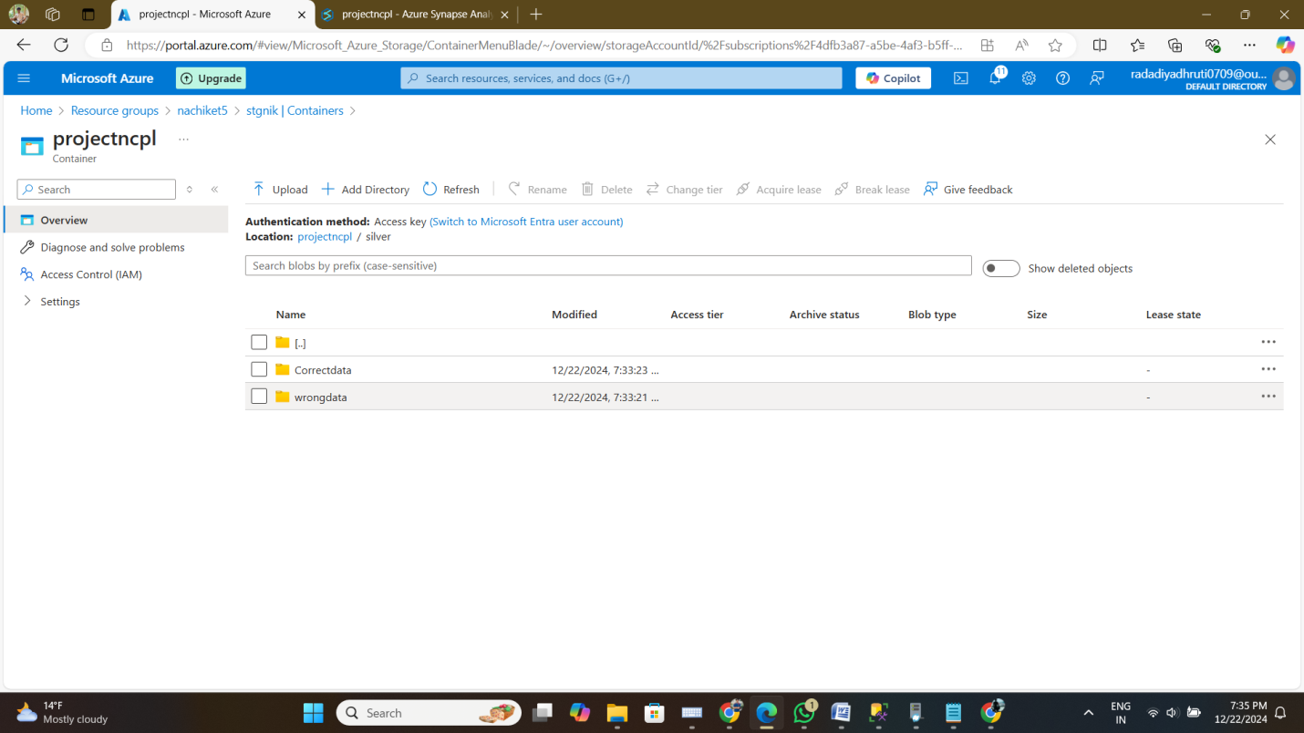

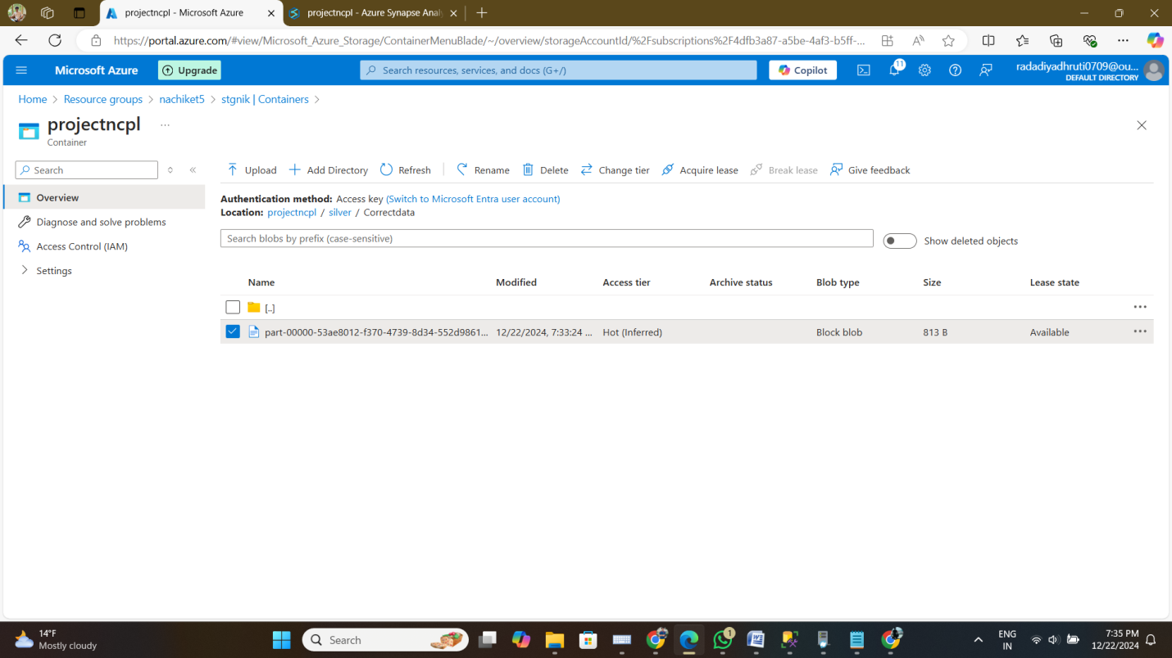

1. **Data Processing for SCD Type 1**
   * **Objective:** Use data from the **Silver** folder to implement Slowly Changing Dimension (SCD) Type 1 logic and store the results in a new Delta format.

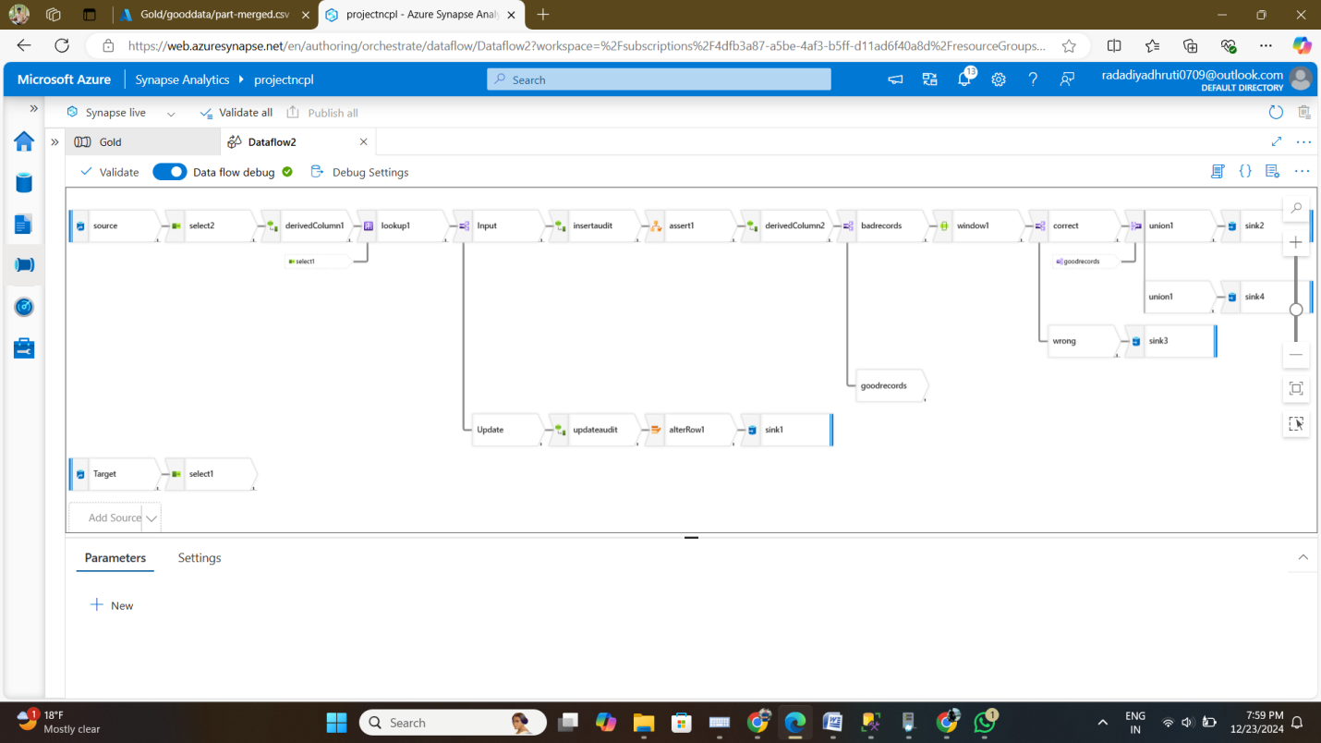

* + **Expected Output:**
    - A folder named **Gold** in the Data Lake Gen2 storage account containing processed data with SCD Type 1 implementation in Delta format.

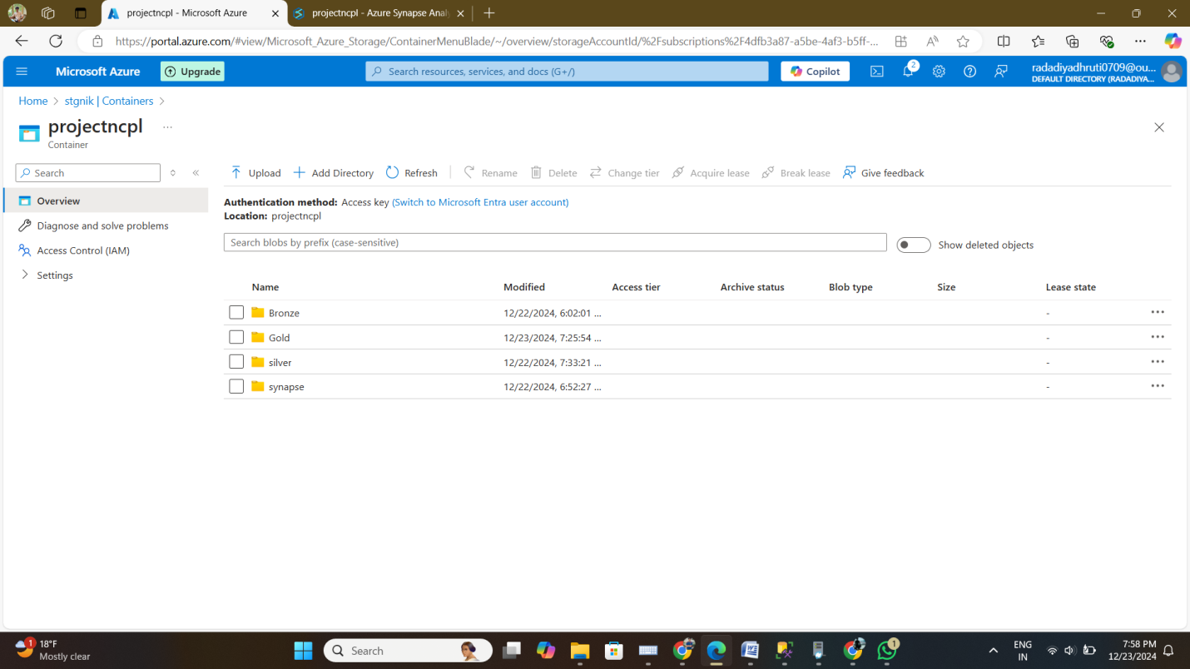

* + - A log or report detailing the changes made during the SCD Type 1 transformation.

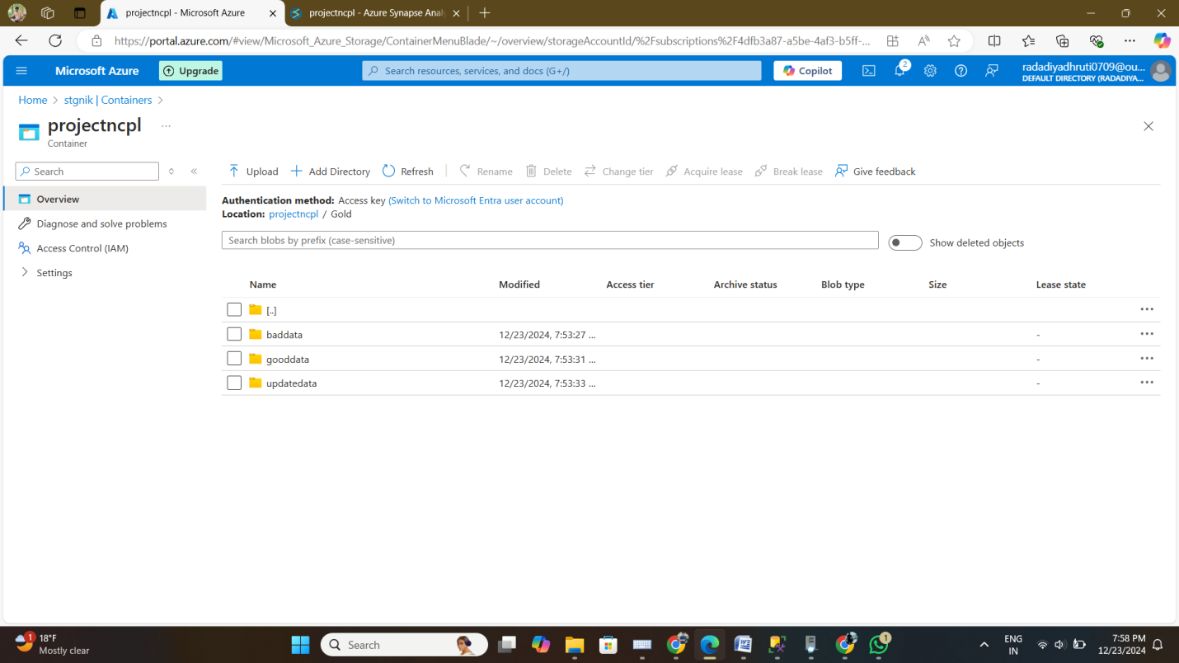

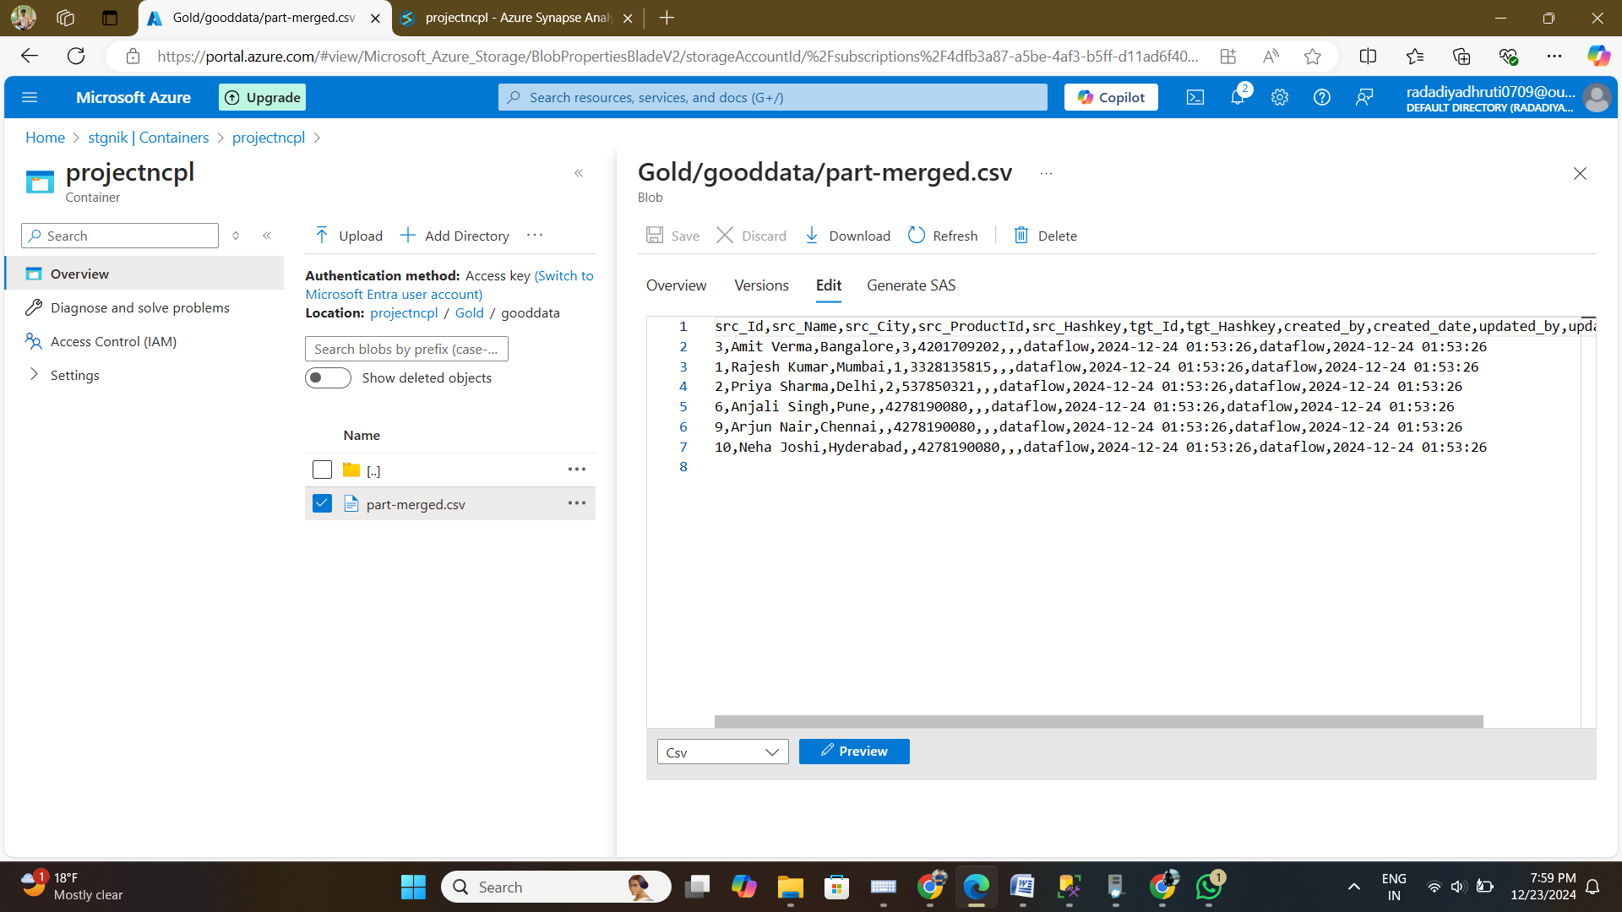

1. **Lakehouse Shortcut**
   * **Objective:** Create a shortcut in the Lakehouse to access the data stored in the Data Lake Gen2 storage account.

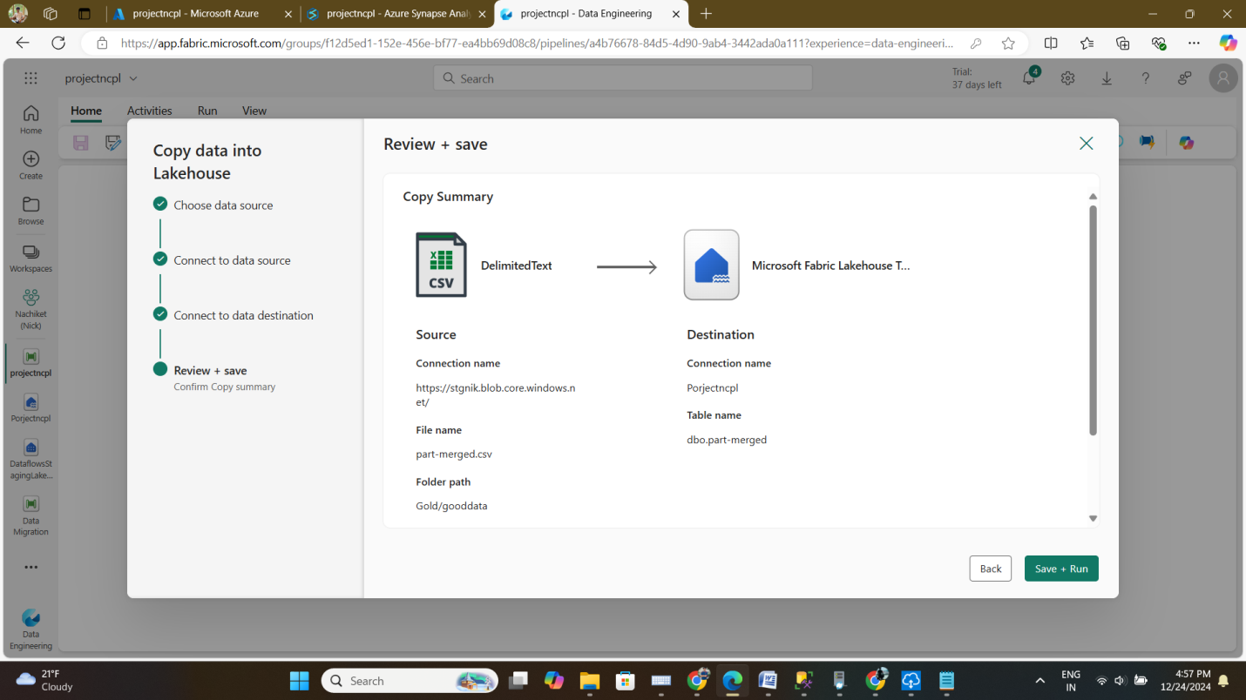

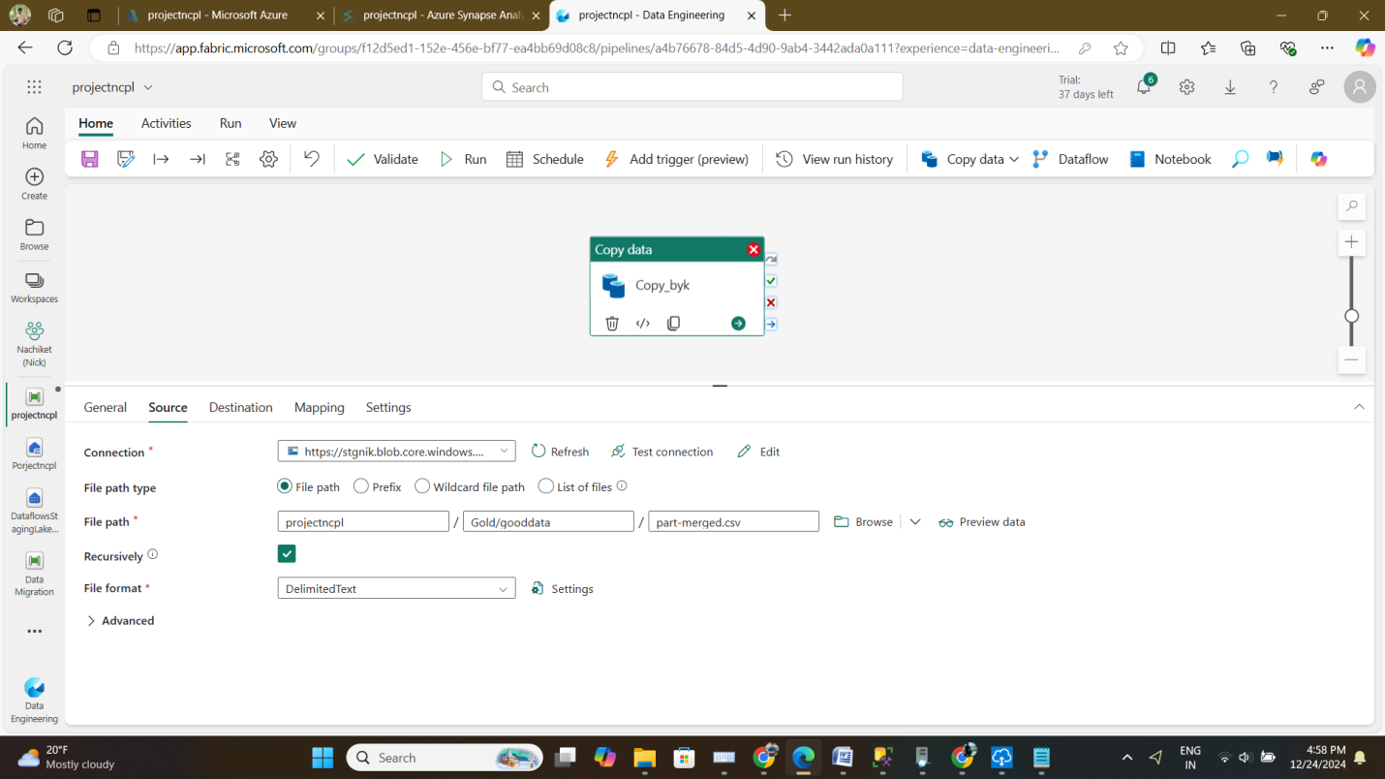

* + **Expected Output:**
    - A functional shortcut in the Lakehouse pointing to the **Gold** folder in the Data Lake Gen2 storage account.

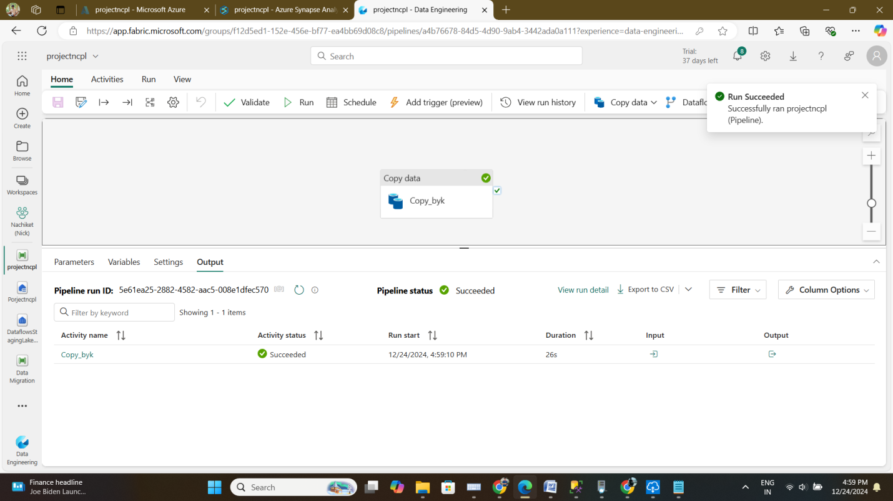

* + - Verification that the shortcut provides seamless access to the data.

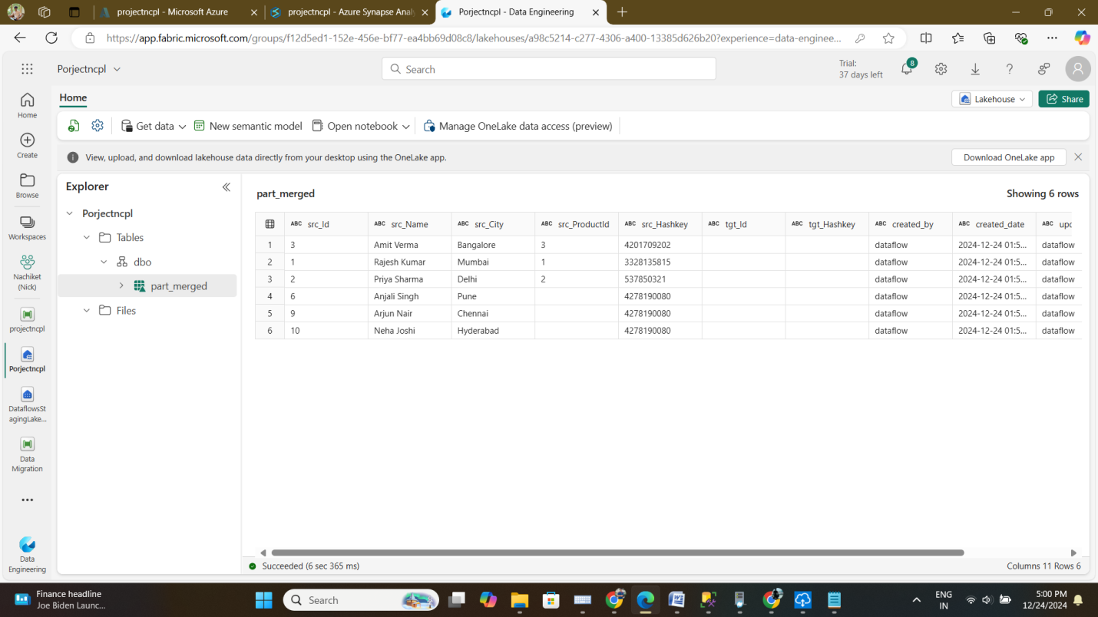

1. **Reporting in Fabric**
   * **Objective:** Use the Lakehouse data to generate a report in Fabric.
   * **Expected Output:**
     + A comprehensive report based on the data in the Lakehouse.

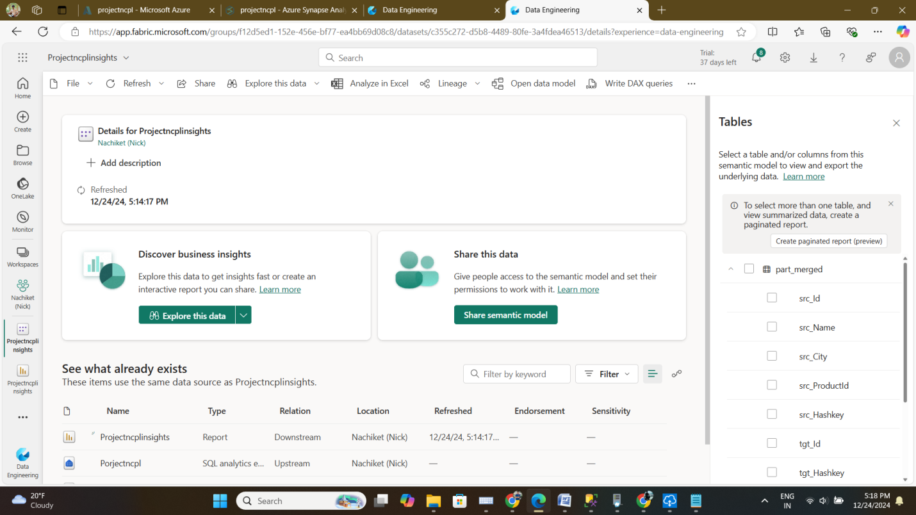

* + - Visualizations, insights, and metrics relevant to the data processed.

